Assignment Report

Topic: CYBER SECURITY: Technical Architectures, Emerging Threat Landscapes, and Strategic Mitigation Frameworks
Prepared For:  - Mr. Tashreef Muhammad  - Southeast University  - Department of CSE | Prepared By:  - Taus Elham Tamjid (ID: 2026000000195)  - Ratul Ahmmed (ID: 2026000000189)  - Saif Ibn Rashid Tahsin (ID: 2026000000185)  - Sumaiya akter sayma (ID: 2026000000205)

Introduction
In today's digital world, technology plays an important role in communication, business, education, and government services. As the use of digital systems continues to grow, the risk of cyber threats and security breaches has also increased.
Cyber Security is the practice of protecting computers, networks, systems, and data from unauthorized access, attacks, and damage. It helps ensure the Confidentiality, Integrity, and Availability (CIA Triad) of information.
Cyber attacks such as phishing, malware, ransomware, and DDoS attacks can cause financial losses, data theft, and disruption of services. Therefore, organizations and individuals must adopt effective security measures to protect their digital assets. Understanding Cyber Security is essential for maintaining a safe and secure digital environment.

Main Discussion

1. Core Domains of Cyber Security
Effective cybersecurity requires a multi-layered defensive approach across key technological domains:
- Network Security: Secures incoming and outgoing data traffic. It utilizes Firewalls to filter malicious packets and deploys a Demilitarized Zone (DMZ) to isolate public-facing servers, shielding the core internal network.
- Cloud Security: Protects assets across IaaS, PaaS, and SaaS environments. It replaces physical perimeters with Identity and Access Management (IAM), utilizing data encryption and authentication protocols like SAML and OAuth.
- Application Security: Emphasizes "Security by Design." It integrates secure coding practices, regular code reviews, unit testing, and sandboxing to eliminate vulnerabilities during the software development lifecycle.
2. Major Cyber Threats and Attack Vectors
Modern cyber threats are increasingly sophisticated, with the primary attack vectors being:
- Phishing: Social engineering tactics using deceptive emails or websites to steal sensitive credentials.
- Malware: Malicious code (viruses, ransomware, Trojans) designed to compromise or disrupt systems.
- Ransomware: A malware strain that encrypts organizational data, demanding financial ransoms for decryption.
- DDoS Attacks: Floods networks with massive traffic volumes, making critical services completely unavailable.
3. Strategic Mitigation and Defense
Organizations can structurally minimize risk exposure by implementing the following core controls:
- Security Frameworks: Adopting standard architectures like the NIST Cybersecurity Framework to systematically Identify, Protect, Detect, Respond, and Recover from threats.
- Human Firewall: Conducting continuous employee awareness training to mitigate risks from social engineering and password negligence.
- Technical Controls: Enforcing Multi-Factor Authentication (MFA), end-to-end encryption, and automated vulnerability scanning.
Figure 1: The CIA Triad Model
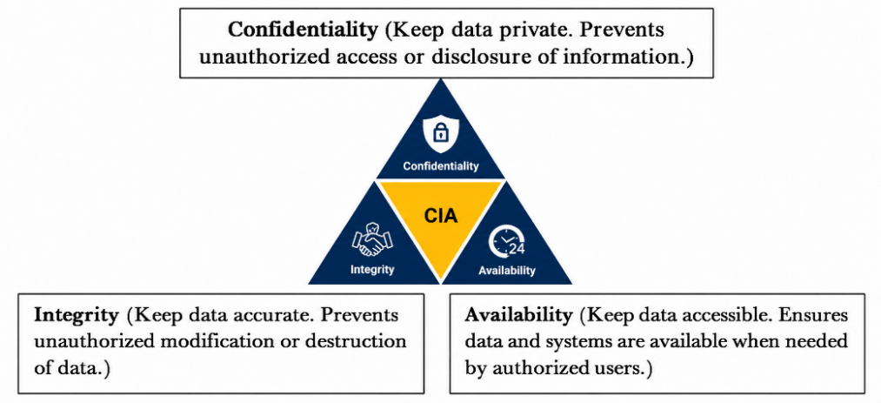
Caption: Figure 1: The Core Pillars of Cyber Security Architecture (CIA Triad) [Self-refined using conceptual assets]
Figure 2: The Anatomy of a Phishing Attack Workflow
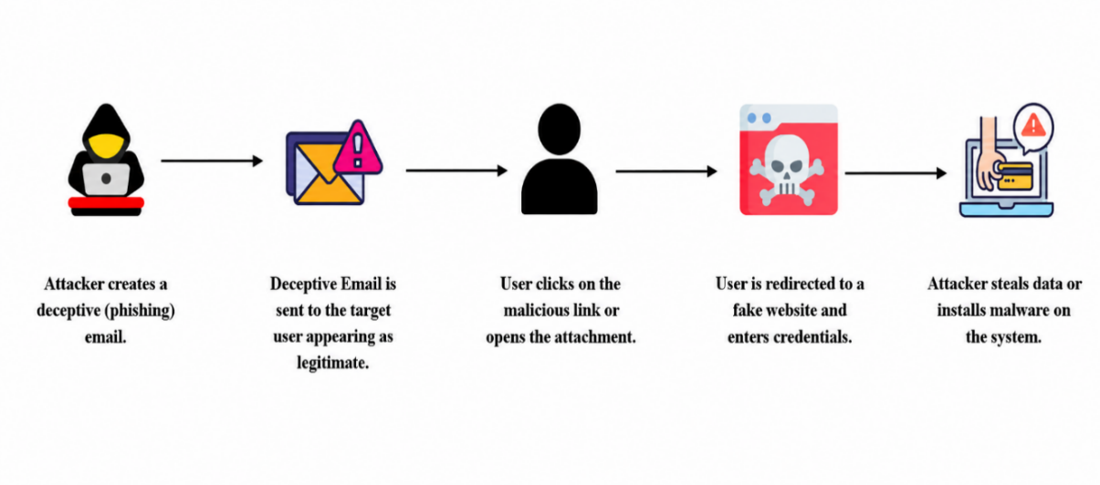
Caption: Figure 2: Flowchart diagram detailing the operational sequence of a social engineering
Data Table & Chart Explanation

Cyber Attack Type | Percentage (%)
Phishing | 40
Malware | 25
Ransomware | 15
DDoS Attacks | 12
Password Attacks | 8

Explanation of the Chart: The chart highlights that Phishing remains the most dominant threat vector at 40%, demonstrating that social engineering is the primary entry point for attackers. Malware follows as the second-highest risk at 25%, while Ransomware and DDoS attacks account for 15% and 12% respectively, showing a continuous threat to network availability and data integrity. Lastly, Password attacks stand at 8%, emphasizing the vulnerability of weak credentials. Overall, this data indicates that organizations must prioritize anti-phishing training, robust malware protection, and strong authentication systems to mitigate modern cyber risks effectively.

Conclusion
Cyber security has become an essential part of modern digital life, protecting systems, networks, and data from a wide range of cyber threats. As cyber attacks such as phishing, malware, ransomware, password attacks, and DDoS attacks continue to increase, organizations must adopt effective security measures to reduce risks. Strong authentication methods, regular software updates, employee awareness training, and modern security frameworks play a vital role in safeguarding digital assets. Therefore, a proactive and well-planned cyber security strategy is necessary to ensure the confidentiality, integrity, and availability of information in today's interconnected world.
References
- IBM Security. (2024). Cost of a Data Breach Report 2024. IBM Corporation.
- National Institute of Standards and Technology (NIST). (2024). The NIST Cybersecurity Framework (CSF) 2.0. U.S. Department of Commerce.
- Infosecurity Magazine. (2024, December 18). Phishing Attacks Double in 2024.
- Ussher-Eke, D. (2025). From awareness to action: Designing effective cybersecurity training programs. International Journal of Science and Research Archive.
- American Power Conversion (APC). (2005). Fundamental Principles of Network Security. White Paper #101.
- Wikipedia. (2026). Computer security.
Team Member Contribution
NAME | ID | Contribution
Taus Elham Tamjid | 2026000000195 | I authored and thoroughly refined the introduction and major cyber threats sections of the report. Additionally, I organized the core dataset and generated the statistical chart within Microsoft Excel. Finally, I designed and structured the comprehensive slide layout for our team's oral presentation.
Ratul Ahmmed | 2026000000189 | I wrote and formatted the entire main discussion section of the report. Additionally, I assisted in gathering cyber mitigation data and ensured the successful integration of our Excel charts.
Saif Ibn Rashid Tahsin | 2026000000185 | I initialized and structured our group's public GitHub repository and its README.md workflow. Additionally, I designed and integrated the technical workflow diagrams used throughout the report.
Sumaiya akter sayma | 2026000000205 | I conducted academic research to collect credible references for the bibliography. Additionally, I formatted the mandatory AI usage log and assisted in drafting the final conclusion.

Use of AI Tools (AI Usage Log)
Tool Used | Purpose | Example Prompt (Short) | Output Used | Modification Done | Verification Method | Who Used It
Gemini & ChatGPT | Formatting report, structuring slides, and validating Excel chart formulas. | "Outline 10 presentation slides and give a clean Excel chart design for cyber attack percentages." | Presentation layout and Excel formatting suggestions. | Integrated the data into Excel, generated the chart, and customized slide texts. | Manually verified chart percentages sum to 100% and cross-checked rules. | 2026000000195
ChatGPT | Gathering structured points for network and cloud security definitions. | "Explain Network Security layers (DMZ) and Cloud Security (IAM) simply." | Conceptual explanations and key technical terminologies. | Paraphrased and rewrote the text to fit the Main Discussion section. | Cross-checked with textbook definitions. | 2026000000189
Grok | Researching recent 2024-2025 cyber threat data and statistics. | "Give latest statistics on phishing and ransomware attacks." | Percentage data and attack statistics. | Combined the numbers into the Excel data table and report. | Cross-checked with IBM Security Report. | 2026000000185
Notebook  LM | Analyzing reference documents for strategic mitigation frameworks. | "Summarize key points from the security reference PDF." | Summary of NIST CSF 2.0 framework functions. | Extracted essential points for the strategic defense section. | Verified with original NIST documentation. | 2026000000205

